Tracing the Christ: Visualizing Messianic Prophecies through the Biblical Canon

Sydni Cobb
Department of Computing Sciences and Mathematics, Franklin University
DATA 605: Data Visualization and Reporting
Dr. James O. Webb, Jr.
May 10, 2025

Introduction and Background
In this final project, I created a visualization connecting Messianic prophecies found in the Old and New Testaments of the biblical canon. As a Christian, I am foremost motivated by the great commission, found in the book of Matthew, to “make disciples of all nations” (YouVersion, n.d.). There is no limit to the ways in which the gospel message may be spread, so I have attempted to be a messenger via Tableau. This medium offers a new approach to evangelism by presenting a new perspective to analytical thinkers who appreciate facts and data. It also allowed me to challenge myself to visualize something not typically associated with data analysis. The ability to articulate the intertextuality of the person of Christ throughout the Bible could strengthen the faith of believers while also making a case to non-believers.
Christianity deeply marks the framework of Western culture. Wikipedia describes Christianity in relation to culture and Western society as “intricately intertwined” (Wikipedia contributors, n.d.), noting things such as schooling, medical care, art, philosophy, and politics. It also mentions the major holidays Christmas and Easter—both rooted in Christianity yet popular among non-Christians. Pew Research Center found 87% of non-religious people celebrate Christmas, with 68% of that group considering it more of a “cultural” holiday (Pew Research Center, 2013). Wikipedia also notes how the Gregorian Calendar is adopted internationally and is itself “measured from an estimation of the date of Jesus's birth” (Wikipedia contributors, n.d.). Another Pew Research study concludes that the decline of Christianity in the U.S. has slowed and possibly even “leveled off” (Pew Research Center, 2025). One would have trouble disputing Christianity’s influence on culture. Examining the Bible through data visualization can reintroduce it to a secular society.
The question I am looking to answer is, “Where are Old Testament prophecies about Christ fulfilled in the New Testament of the biblical canon?” For Christians, this visualization will aid in explaining our faith in Christ by presenting the facts behind the scriptures. Christ fulfilled every prophecy connected to the Messiah. These scriptures were written by dozens of people in several different countries over hundreds of years and somehow all connect. Visualizing these fulfilled prophecies and mapping the locations of the writers will provide a nuanced perspective on scripture. Of course, it takes faith to believe that any of it is true; however, the variance between Old Testament and New Testament writers—both by physical location and time—begs the question, about this story that has sold between 5 and 7 billion copies (Foust, 2023), “How could they have done this outside of divine intervention?”
Datasets
The biggest challenge in this project was instead of using already-built datasets, I decided to build a dataset from scratch. This was necessary as I wanted the scope of my data to be centered on prophecies that were theologically and thematically focused on the person of Christ, the Messiah. There are hundreds of prophecies throughout scripture, and with Christ as the central focus of the Bible, it could be argued that they all have to do with him; however, I was seeking prophecies with a more distinct, explicit focus on Christ’s arrival, birth, life, death, and resurrection. In researching data sets related to Messianic prophecies, the data sets I found were not wholly thematically or theologically catered to my scope. I would have been doing a disservice to the integrity of those datasets if tried using them while cherry-picking the data to my liking. To mediate this issue, I decided to compile a list of prophecies that are generally agreed upon by scholars as being specifically thematically and theologically related to the person of Christ. I then expanded upon these by compiling two sets of scriptures for each prophecy: prophecies (Old Testament) and fulfillments (New Testament).
To build my dataset, I created Microsoft Excel workbooks with explicit headers and utilized ChatGPT, an artificial intelligence (AI) tool, to find verifiable sources fit to my search criteria and fill in the workbooks with data from those sources. Developing these datasets to meet my criteria while being Tableau-friendly required hours of trial and error over multiple days. Writing and rewriting the queries to suit my desired output; modifying the fields to ensure all necessary data was accounted for and unnecessary data was omitted; and reworking the datasets—sometimes completely ridding of or merging them—are just some of the revisions I performed. To remain integral, I only used ChatGPT to carry out the data gathering and to provide references for each source returned. I did not use it to develop ideas for my analysis or for suggestions on how to visualize the data.
My first workbook (Messianic_Prophecy_Scriptures) has the bulk of the data used in my visualizations, with the following fields:
- Prophecy # (identifier for the prophecies)
- Reference # (identifier for the scriptures)
- Reference (Scripture) (book, chapter, and verse(s))
- Scripture Text (ESV Translation) (scripture text)
- Book (book)
- Testament (testament)
- Author (writer of the scripture)
- Speaker (speaker of the scripture)
- Prophecy? (Boolean)
- Fulfillment? (Boolean)
- Original Language (original language of the scripture)
- Date Written (BCE/CE) (approx. date scripture was written)
- Midpoint Date (midpoint of BCE/CE date ranges)
- Location (location where scripture was written)
- Latitude (geospatial)
- Longitude (geospatial)
The second workbook (Prophecies) contains the fields Prophecy # and Prophecy Description, a short summary of the prophecy. The data for each of these datasets was collected from several Bible research sources, including commentaries, dictionaries, encyclopedias, publishers, and more. Each of these resources has been included in the Reference List. The Prophecies workbook details 63 explicit Messianic prophecies with 63 rows of data. The first workbook further explores each of these 63 prophecies with a total of 459 rows of data. This dataset has a minimum of two rows of data for each prophecy as each prophecy required one prophetic scripture (Old Testament) and one fulfillment scripture (New Testament). Where applicable, I included multiple Old and/or New Testament scriptures in a single prophecy to further support the legitimacy of the prophecy.
Data Story
Scriptures Table
My first visual is a text table of every scripture found in the datasets. It includes the fields Prophecy #, Prophecy Description, Testament, Book, Reference (Scripture), Scripture, Speaker, Location, and Midpoint Date. I added interactive filters for Prophecy Description, Testament, Book, Author, Speaker, Midpoint Date, and Original Language. I chose to add filters for fields not included in the visual to allow users to see the data related to those dimensions without it taking up visual space. This table supports my objective by providing scriptural references for the prophecies all in one place. Having the scriptures stacked and grouped by Testament within each prophecy, along with the optional filters and Location and Midpoint Date data, allows users to compare the authorship of the scriptures. The contrast of the prophecies being prophesied in one place and time and then fulfilled in another should encourage the audience to ponder how such a thing took place outside of divine intervention, considering the communication limitations at the time of the writings.
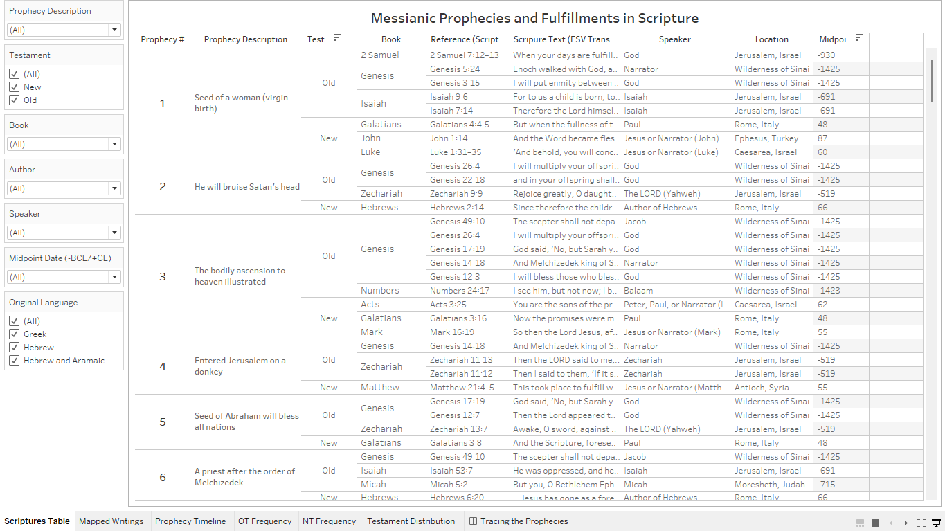 The biggest limitation with the dataset and with this sheet is the Midpoint Date field. This field is a numeric data type instead of a date data type. It was created using the Date Written (BCE/CE) field, which is a string field. Most of the date information was given in ranges that are generally accepted among Biblical scholars, and the midpoint of those values is what appears in the Midpoint Date field. Since the midpoint values are positive and negative, users may not understand why the “date” is formatted as it is, unless they see the edited title of the Midpoint Date filter, which has (-BCE/+CE) added to aid in clarity. Preferably, this field would be a true date field—using the midpoint number is better than nothing, but this is certainly one of the limitations of my dataset. Another limitation and oversight on my part is the occurrence of repeating scriptures within some prophecies. I thought I did my due diligence in weeding out duplicates, but some happened to be missed; fortunately, this only affects the total number of rows within the dataset rather than discrediting the objective in and of itself. For the purposes of my project, I only needed one verse per testament for each prophecy. If I were to redo this project, I would either only provide one set of scripture per prophecy or instead make sure to do multiple readings of the workbook to ensure there are no duplicates.
Mapped Writings
My next visual is a map that plots the latitude and longitude of the approximate locations where each scripture in the dataset was written. The Latitude and Longitude fields both come from the Messanic_Prophecy_Scriptures workbook. There are 9 locations included in this map, which are the generally agreed upon locations for the scriptures in the dataset. The Testament field is on the Color shelf to further distinguish the locations. To support the interactivity of this visual and allow users to explore the data, I included the fields Midpoint Date (titled Date (-BCE/+CE)), Prophecy #, Author, Book, and Reference (Scripture) as optional filters along with Location. There is also a tooltip linked to the locations revealing further details on Location, Prophecy (coded to include both the Prophecy # and Prophecy Description), Testament, Scripture (coded to include the scripture reference unique identifier, the scripture reference, and the scripture text), Author, Speaker, Date, and Original Language.
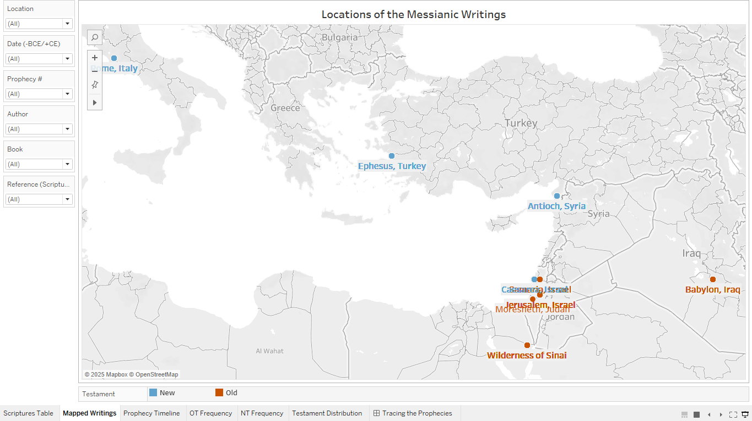 The goal is for users to apply filters to the sheet and review the information on the tooltips while comparing the mapped locations. For example, if you filter Prophecy # to 9, the map will present the locations of the Old and New Testament writings related to that prophecy. The locations populated with this selection show the New Testament in the upper-left of the map and the Old Testament writings in the lower-right of the map. Examining the tooltips for this selection reveals that these writings were written approximately 750 years apart and in two different languages. This worksheet is not only insightful but fun to play around with, allowing you to examine the locations of the Messianic writings from several angles.
Prophecy Timeline
The next worksheet attempts to present the Old and New Testament connections between prophecies. This visual has the greatest number of limitations, mostly stemming from the issue with the Midpoint Date field. Since this field is a whole number and not a date, it is a scatterplot with Line Marks. To plot prophecies and fulfillments, I created a calculated field named Axis Point, with the following code: IF [Testament] = "Old" THEN 1 ELSE 2 END. This field was then added to the Rows shelf, assigning Old Testament prophecies to 1 on the y-axis and New Testament fulfillments to 2 on the y-axis. The scriptures would be plotted according to their Midpoint Date value on the x-axis, and the Line Mark transformed it into a type of line chart.
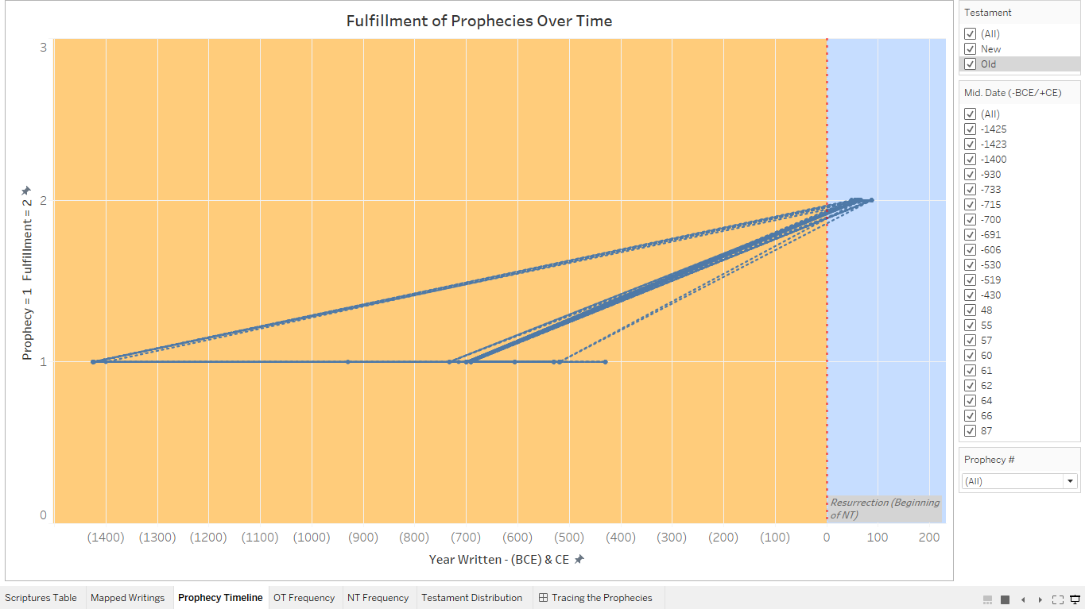 There are several issues with this chart. First, it would be ideal to have true date values to make it a true line chart. This would allow for a different field to be on the Rows shelf and the points would not all start and end on the same y-axis points. Next, because of those issues, the visual is cluttered, without manual filtering. Adding the Testament field to the Color shelf results in two separate lines, and putting the Prophecy # field on the Color shelf does not help with distinguishing the lines, because there are 63 prophecies and a lot of overlap in the dates. I added a Reference Line at 0 on the x-axis and changed the color of the pane both before and after that Reference Line to aid with differentiating the Old Testament prophecies from the New Testament fulfillments. This helps some, but the visual is still mostly cluttered and ugly, when left unfiltered. I did add optional filters for Testament, Midpoint Date, and Prophecy # because those selections allow for greater insight can be pulled from the visual. Selecting a number in the Prophecy # filter shows the BCE midpoint dates for the prophecies connected with a line to CE dates of the fulfillments. There are also Tooltips on each mark highlighting the Date, Prophecy #, Axis Point (Testament), and Prophecy (Prophecy Description). These tooltips combined with filtering make the visual more usable, but overall, this visual requires a lot of reworking to make it presentable.
OT and NT Frequency
The next two worksheets show the count of prophecies within each book for the Old and New Testaments. With the Book field on the Columns shelf and the Distinct Count of Prophecy # on the Rows shelf, we see the distribution of prophecies in each of the books in our dataset. The worksheets are filtered to the Old Testament and New Testament, respectively. Tooltips for each Book column detail the Testament, Book, Original Language, distinct count of prophecies, and total count of scripture. The labels above each column detail the distinct count of prophecies in each book. I put the Original Language field on the Color Mark, to give users some insight into the language the books were originally written in. Optional filters for Location and Midpoint Date were added so users can explore some of these details in relation to the books and prophecies. One limitation of these visuals is found in the Tooltips, as the count of scriptures is incorrect for some of the books, since there are duplicate references. Overall, these visuals are visually clean, easy to understand, and fun to explore.
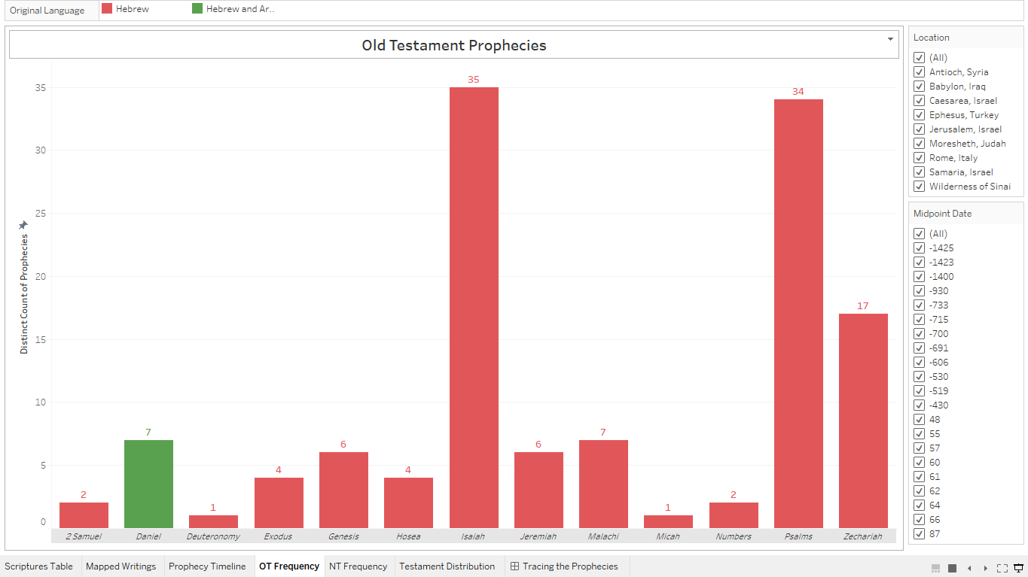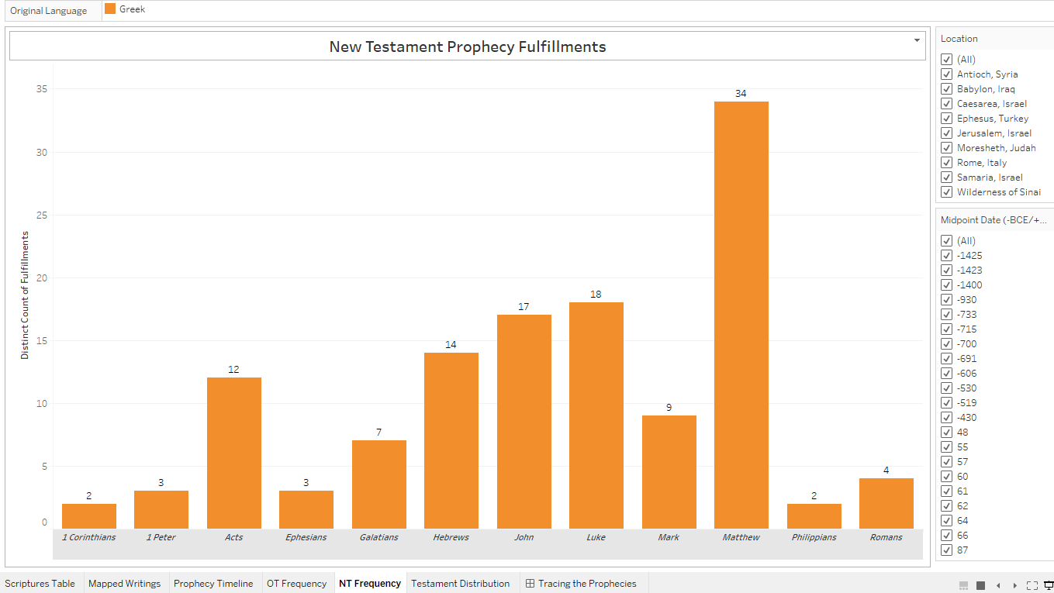Testament Distribution
My final worksheet includes Treemaps with the distribution of scripture within each Testament. I formatted these Treemaps with Book is on the Color Mark, Count of Reference # on the Size Mark, and Book on the Detail Mark followed by Reference # on the Detail Mark. With each scripture, a Tooltip reveals the related Book, Author, Date Written (BCE/CE), Original Language, Scripture (coded with both the Reference (Scripture) and Scripture Text fields), and Speaker. I also added an optional filter for Testament and kept the Book Color Legend, giving users more control over what passages they view. This visual is a decent tool for comparing books within and between the Testaments based on the amount of Messianic prophetic passages each book and Testament contain. Again, a downfall is the inaccuracy of scripture counts due to duplicates in the data source, but overall, these Treemaps are visually appealing and give a great deal of insight into the makeup of the Testaments.
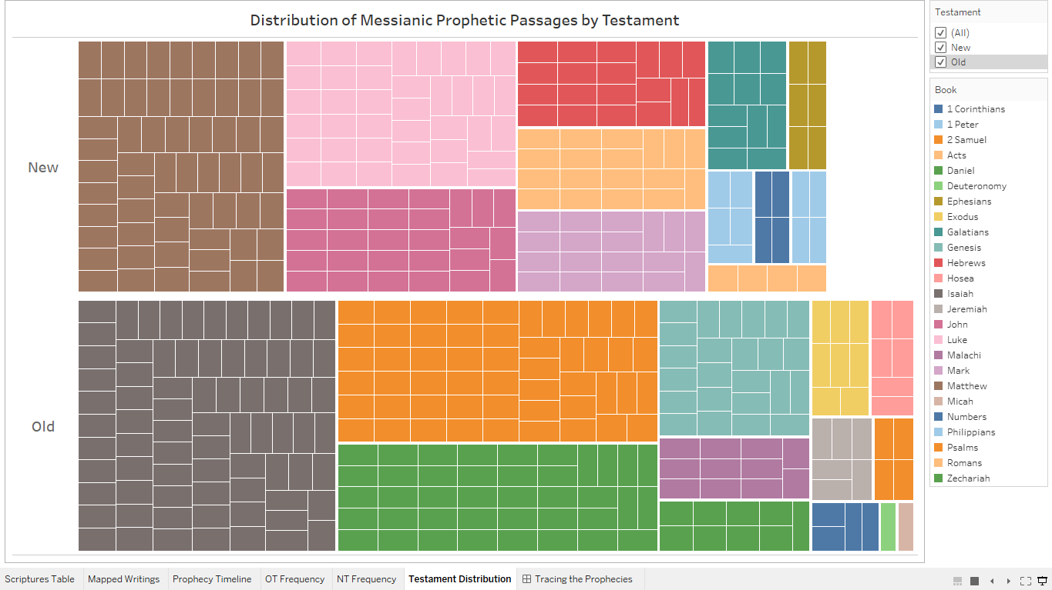Tracing the Prophecies
My dashboard, entitled Tracing the Prophecies, combines the map, text table, and line chart worksheets. This interactive dashboard allows users to make selections in any of the sheets that will then translate to the others, presenting details about the locations, prophecies, and scriptures from several angles. A text box in the upper-right corner encourages users to explore the data by using the nearby filters or making selections directly on the sheets. I chose filters that would make the least number of vital changes to the main worksheets after the filters were removed. For example, I initially had a Testament filter, but because this filter is necessary to the Testament Frequency worksheets, I removed it. Though the limitations on each of these worksheets naturally appear in the dashboard, the selections offer much insight into the details of the prophecies.
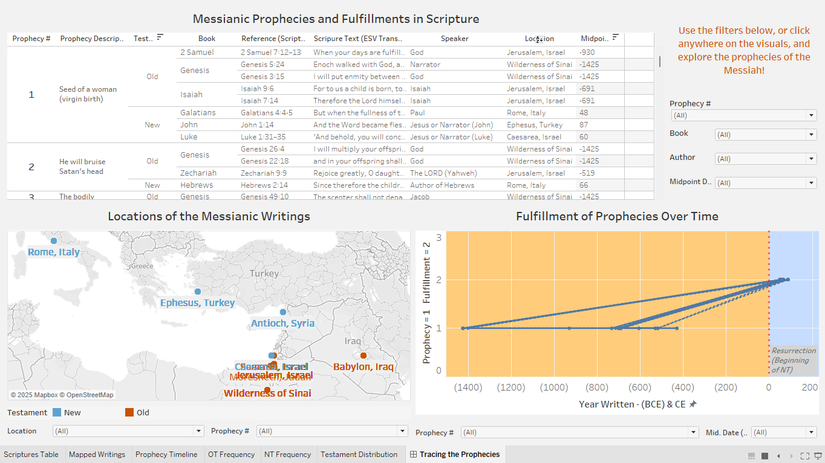Summary and Conclusions
Overall, this Tableau workbook does a decent job at visualizing the connections between Messianic prophecies and the fulfillments of those prophecies throughout the biblical canon. Though there are limitations, mostly resulting from a self-made dataset with several oversights and roadblocks, the worksheets work well together to show how much the prophetic scriptures interrelate while also having an astonishing amount of variance. Though this is limited to only 63 prophecies, the foundation of this dataset consists of a considerable amount of information. My hope was to encourage users to get their hands dirty, really digging into the data through the interactive filters. These filters highlight both the similarities and variances of the scriptures related to the same prophecies, and this meets my overall objective. In hindsight, I might adjust the scope of my project to use a ready-made dataset and avoid some of the limitations I faced; however, I learned a lot about building datasets and the quality checks and research necessary to do so.
In conclusion, I believe this workbook does a fair job at visualizing the complex continuity of Messianic prophecies throughout the Bible. By showing the similarities between the text itself in contrast to the variance of the location and date details, for example, this presents the puzzling question of “How is this possible?” Other than limitations in the datasets, there will always be an element of faith required in believing whether this supports the existence of Jesus Christ. Faith, at its core, is a decision to believe something is true, and it does not always rely on verifiable proof to exist in someone; however, I believe visualizations such as this demonstrate the collision of faith and facts, hopefully encouraging the audience to dig deeper into the possibility of a divine God.

References
Achtemeier, P. J., Green, J. B., & Thompson, M. M. (2001). *Introducing the New Testament: Its
Literature and Theology*. Eerdmans.
Barker, K. L. (Ed.). (2002). *The NIV Study Bible* (Fully rev. ed.). Zondervan.
Bible Gateway. (n.d.). *Bible search and study tools*.
Bible Gateway. (n.d.). *Bible Search and Study Tools*. https://www.biblegateway.com/
Bible Gateway. (n.d.). *Interlinear Bible tools*.
Blue Letter Bible. (n.d.). *Bible commentaries and interlinear tools*.
Blue Letter Bible. (n.d.). *Lexicons and language tools*.
Bruce, F. F. (1981). *The New Testament Documents: Are They Reliable?* Eerdmans.
Carson, D. A., & Moo, D. J. (2005). *An Introduction to the New Testament* (2nd ed.).
Zondervan.
Carson, D. A., & Moo, D. J. (2005). *An introduction to the New Testament* (2nd ed.).
Zondervan.
Crossway. (2001). *ESV Study Bible* (English Standard Version). Crossway Bibles.
Crossway. (2016). *The Holy Bible, English Standard Version*. ESV Text Edition. Crossway Bibles.
https://www.esv.org/
Dyer, C. H., & Merrill, E. H. (2001). *The Old Testament Explorer: Discovering the Essence,
Background, and Meaning of Every Book in the Old Testament*. Thomas Nelson.
Eerdmans, D. (1999). *Eerdmans Dictionary of the Bible*. Wm. B. Eerdmans Publishing Co.
Elwell, W. A., & Beitzel, B. J. (1988). *Baker Encyclopedia of the Bible* (Vol. 2). Baker Book
House.
Elwell, W. A., & Beitzel, B. J. (1988). *Baker Encyclopedia of the Bible* (Vol. 2). Baker Book
House. Köstenberger, A. J., & Patterson, R. D. (2011). *Invitation to Biblical
Interpretation: Exploring the Hermeneutical Triad*. Kregel Academic.
Elwell, W. A., & Beitzel, B. J. (1988). *Baker Encyclopedia of the Bible*. Baker Book House.
ESV Bible Editorial Team. (2016). *The ESV Study Bible*. Crossway.
Fee, G. D., & Stuart, D. (2014). *How to Read the Bible for All Its Worth* (4th ed.). Zondervan.
Foust, M. (2023, January 5). The Bible is consistently the best-selling book of the year. Crosswalk.
https://www.crosswalk.com/headlines/contributors/michael-foust/the-bible-is-consistently
the-best-selling-book-of-the-year.html
Freedman, D. N. (Ed.). (2000). *Eerdmans Dictionary of the Bible*. Eerdmans.
Geisler, N. L. (1999). *A Popular Survey of the Old Testament*. Baker Books.
GotQuestions Ministries. (n.d.). *GotQuestions.org Bible Q&A*.
Gundry, R. H. (2012). *A Survey of the New Testament* (5th ed.). Zondervan Academic.
Harris, S. L. (2011). *Understanding the Bible* (8th ed.). McGraw-Hill Education.
Hindson, E., & Towns, E. L. (Eds.). (2013). *Illustrated Bible Survey: An Introduction*. B&H
Publishing Group.
Hindson, E., & Yates, G. A. (Eds.). (2012). *The Essence of the Old Testament: A Survey*. B&H
Academic.
Holman Bible Editorial Staff. (2014). *Holman Illustrated Bible Handbook*. B&H Publishing
Group.
Holman Bible Publishers. (2012). *Holman Illustrated Bible Handbook*. B&H Publishing Group.
Holy Bible, English Standard Version. (2001). Crossway Bibles.
Kaiser, W. C., & Garrett, D. A. (2006). *The NIV Archaeological Study Bible*. Zondervan.
Klein, W. W., Blomberg, C. L., & Hubbard, R. L. (2017). *Introduction to Biblical Interpretation*
(3rd ed.). Zondervan Academic. Köstenberger, A. J., & Patterson, R. D. (2011). *Invitation
to Biblical Interpretation: Exploring the Hermeneutical Triad*. Kregel Academic.
Kostenberger, A. J., Kellum, L. S., & Quarles, C. L. (2009). *The Cradle, the Cross, and the Crown:
An Introduction to the New Testament*. B&H Academic.
LaSor, W. S., Hubbard, D. A., & Bush, F. W. (1996). *Old Testament Survey: The Message, Form,
and Background of the Old Testament*. Eerdmans.
Liberty University. (n.d.-a). Second Person Journal. Liberty University Digital Commons.
https://digitalcommons.liberty.edu/second_person/
Liberty University. (n.d.-b). What if the Trinity is not eternal? [PDF]. Liberty University Digital Commons.
https://digitalcommons.liberty.edu/cgi/viewcontent.cgi?article=1154&context=second_person
Logos Bible Software. (n.d.). *Original language tagging and lexicons*. Faithlife Corporation.
Logos Bible Software. (n.d.). *Passage guides and speaker tagging*. Faithlife Corporation.
MacArthur, J. (2006). *The MacArthur Bible Commentary*. Thomas Nelson.
Metzger, B. M. (2001). *The Bible in Translation: Ancient and English Versions*. Baker Academic.
Nelson, T. (Ed.). (2003). *Nelson’s Complete Book of Bible Maps and Charts* (Revised ed.).
Thomas Nelson.
OpenBible.info. (n.d.). *Bible Geocoding*. Retrieved May 7, 2025, from Richards, L. O. (1991). *The Bible Reader's Companion*. Word Publishing.
Pew Research Center. (2013, December 18). Celebrating Christmas and the holidays, then and now.
https://www.pewresearch.org/religion/2013/12/18/celebrating-christmas-and-the-holidays
then-and-now/
Pew Research Center. (2025, February 26). Decline of Christianity in the U.S. has slowed, may have
leveled off. https://www.pewresearch.org/religion/2025/02/26/decline-of-christianity-in-the-us
has-slowed-may-have-leveled-off/
Richards, L. O. (1991). *The Bible Reader’s Companion*. Victor Books.
Tenney, M. C., & Barabas, S. (1975). *The Zondervan Encyclopedia of the Bible* (Vols. 1–5).
Zondervan.
The Holy Bible, English Standard Version. (1 Corinthians 5:7).
The Holy Bible, English Standard Version. (1 Peter 2:24).
The Holy Bible, English Standard Version. (1 Peter 2:7).
The Holy Bible, English Standard Version. (2 Samuel 7:12–13).
The Holy Bible, English Standard Version. (Acts 13:47).
The Holy Bible, English Standard Version. (Acts 1:9).
The Holy Bible, English Standard Version. (Acts 2:31).
The Holy Bible, English Standard Version. (Acts 3:25).
The Holy Bible, English Standard Version. (Daniel 7:13-14).
The Holy Bible, English Standard Version. (Daniel 7:13–14).
The Holy Bible, English Standard Version. (Daniel 7:14).
The Holy Bible, English Standard Version. (Ephesians 4:8).
The Holy Bible, English Standard Version. (Exodus 12:21–27).
The Holy Bible, English Standard Version. (Genesis 12:3).
The Holy Bible, English Standard Version. (Genesis 17:19).
The Holy Bible, English Standard Version. (Genesis 22:18).
The Holy Bible, English Standard Version. (Genesis 26:4).
The Holy Bible, English Standard Version. (Genesis 49:10).
The Holy Bible, English Standard Version. (Hebrews 1:3).
The Holy Bible, English Standard Version. (Hebrews 5:5–6).
The Holy Bible, English Standard Version. (Hebrews 8:6-13).
The Holy Bible, English Standard Version. (Hebrews 8:6–13).
The Holy Bible, English Standard Version. (Hebrews 9:28).
The Holy Bible, English Standard Version. (Hosea 11:1).
The Holy Bible, English Standard Version. (Isaiah 11:1).
The Holy Bible, English Standard Version. (Isaiah 40:3).
The Holy Bible, English Standard Version. (Isaiah 42:6).
The Holy Bible, English Standard Version. (Isaiah 49:8).
The Holy Bible, English Standard Version. (Isaiah 53:11).
The Holy Bible, English Standard Version. (Isaiah 53:12).
The Holy Bible, English Standard Version. (Isaiah 53:3).
The Holy Bible, English Standard Version. (Isaiah 53:4–5).
The Holy Bible, English Standard Version. (Isaiah 53:5).
The Holy Bible, English Standard Version. (Isaiah 53:7).
The Holy Bible, English Standard Version. (Isaiah 53:9).
The Holy Bible, English Standard Version. (Isaiah 7:14).
The Holy Bible, English Standard Version. (Isaiah 8:14).
The Holy Bible, English Standard Version. (Isaiah 9:1–2).
The Holy Bible, English Standard Version. (Isaiah 9:6).
The Holy Bible, English Standard Version. (Jeremiah 31:31).
The Holy Bible, English Standard Version. (Jeremiah 31:31-34).
The Holy Bible, English Standard Version. (Jeremiah 31:31–34).
The Holy Bible, English Standard Version. (John 12:14–15).
The Holy Bible, English Standard Version. (John 19:23–24).
The Holy Bible, English Standard Version. (John 19:28–29).
The Holy Bible, English Standard Version. (John 19:28–30).
The Holy Bible, English Standard Version. (John 19:33-36).
The Holy Bible, English Standard Version. (John 19:33–36).
The Holy Bible, English Standard Version. (John 19:34-37).
The Holy Bible, English Standard Version. (John 19:34–37).
The Holy Bible, English Standard Version. (John 1:11).
The Holy Bible, English Standard Version. (John 1:14).
The Holy Bible, English Standard Version. (John 20:25-27).
The Holy Bible, English Standard Version. (John 20:25–27).
The Holy Bible, English Standard Version. (Luke 1:17).
The Holy Bible, English Standard Version. (Luke 1:31–35).
The Holy Bible, English Standard Version. (Luke 1:32–33).
The Holy Bible, English Standard Version. (Luke 1:33).
The Holy Bible, English Standard Version. (Luke 22:20).
The Holy Bible, English Standard Version. (Luke 23:18).
The Holy Bible, English Standard Version. (Luke 2:14).
The Holy Bible, English Standard Version. (Luke 3:33).
The Holy Bible, English Standard Version. (Luke 3:34).
The Holy Bible, English Standard Version. (Malachi 3:1).
The Holy Bible, English Standard Version. (Malachi 4:5–6).
The Holy Bible, English Standard Version. (Mark 15:27–28).
The Holy Bible, English Standard Version. (Matthew 11:10).
The Holy Bible, English Standard Version. (Matthew 13:34–35).
The Holy Bible, English Standard Version. (Matthew 1:1).
The Holy Bible, English Standard Version. (Matthew 1:2).
The Holy Bible, English Standard Version. (Matthew 1:22–23).
The Holy Bible, English Standard Version. (Matthew 1:23).
The Holy Bible, English Standard Version. (Matthew 21:4–5).
The Holy Bible, English Standard Version. (Matthew 26:14–15).
The Holy Bible, English Standard Version. (Matthew 26:14–16).
The Holy Bible, English Standard Version. (Matthew 26:31).
The Holy Bible, English Standard Version. (Matthew 26:47–50).
The Holy Bible, English Standard Version. (Matthew 27:12–14).
The Holy Bible, English Standard Version. (Matthew 27:39–40).
The Holy Bible, English Standard Version. (Matthew 27:41–43).
The Holy Bible, English Standard Version. (Matthew 27:57-60).
The Holy Bible, English Standard Version. (Matthew 27:57–60).
The Holy Bible, English Standard Version. (Matthew 27:7).
The Holy Bible, English Standard Version. (Matthew 28:18).
The Holy Bible, English Standard Version. (Matthew 2:15).
The Holy Bible, English Standard Version. (Matthew 2:1–6).
The Holy Bible, English Standard Version. (Matthew 2:23).
The Holy Bible, English Standard Version. (Matthew 3:17).
The Holy Bible, English Standard Version. (Matthew 3:3).
The Holy Bible, English Standard Version. (Matthew 4:13–16).
The Holy Bible, English Standard Version. (Micah 5:2).
The Holy Bible, English Standard Version. (Numbers 24:17).
The Holy Bible, English Standard Version. (Philippians 2:8).
The Holy Bible, English Standard Version. (Psalm 110:1).
The Holy Bible, English Standard Version. (Psalm 110:4).
The Holy Bible, English Standard Version. (Psalm 118:22).
The Holy Bible, English Standard Version. (Psalm 16:10).
The Holy Bible, English Standard Version. (Psalm 22:16).
The Holy Bible, English Standard Version. (Psalm 22:18).
The Holy Bible, English Standard Version. (Psalm 22:22).
The Holy Bible, English Standard Version. (Psalm 22:7–8).
The Holy Bible, English Standard Version. (Psalm 2:7).
The Holy Bible, English Standard Version. (Psalm 34:20).
The Holy Bible, English Standard Version. (Psalm 41:9).
The Holy Bible, English Standard Version. (Psalm 68:18).
The Holy Bible, English Standard Version. (Psalm 69:21).
The Holy Bible, English Standard Version. (Psalm 78:2).
The Holy Bible, English Standard Version. (Romans 9:33).
The Holy Bible, English Standard Version. (Zechariah 11:12).
The Holy Bible, English Standard Version. (Zechariah 11:13).
The Holy Bible, English Standard Version. (Zechariah 12:10).
The Holy Bible, English Standard Version. (Zechariah 13:7).
The Holy Bible, English Standard Version. (Zechariah 9:10).
The Holy Bible, English Standard Version. (Zechariah 9:9).
The SBL Handbook of Style. (2014). *For Biblical Studies and Related Disciplines* (2nd ed.). SBL
Press.
Tov, E. (2012). *Textual Criticism of the Hebrew Bible* (3rd ed.). Fortress Press.
Walton, J. H., & Keener, C. S. (2019). *Cultural Backgrounds Study Bible: Bringing to Life the
Ancient World of Scripture* (NIV ed.). Zondervan.
Wiersbe, W. W. (2007). *The Wiersbe Bible Commentary: Old Testament*. David C. Cook.
Wikipedia contributors. (n.d.). Role of Christianity in civilization. Wikipedia. Retrieved April 19, 2025,
from https://en.wikipedia.org/wiki/Role_of_Christianity_in_civilization
Wright, C. J. H. (2006). *Knowing the Holy Spirit Through the Old Testament*. InterVarsity Press.
Yarbrough, R. W. (2014). *The Letter to the Hebrews*. In D. A. Carson (Ed.), *The New
Testament Commentary Series*. Eerdmans.
YouVersion. (n.d.). Matthew 28 (English Standard Version). Bible.com. Retrieved April 19, 2025, from
https://www.bible.com/bible/59/MAT.28.ESV

This project used OpenAI’s ChatGPT (GPT-4, 2024) to assist with data structuring and reference metadata. All analysis and interpretation were conducted by the student.

